**CHAPTER-5**

**SYSTEM DESIGN**

**5.1 DATABASE SCHEMA DESIGN**

As per the privacy policy of company developers are not allow to show the schema design of the system.

* 1. **DATA DICTIONARY**

1. **User:**

Table 5.1 User

|  |  |  |  |
| --- | --- | --- | --- |
| **Fieldname** | **Datatype** | **Size** | **Constraints** |
| id | Varchar | 50 | Primary key |
| name | Varchar | 100 | Not null |
| email | Varchar | 100 | Not null |
| phone | Numeric | 15 | - |
| password | Varchar | 25 | Not null |

1. **Form:**

Table 5.2 Form

|  |  |  |  |
| --- | --- | --- | --- |
| **Fieldname** | **Datatype** | **Size** | **Constraints** |
| id | Varchar | 50 | Primary key |
| user_id | Varchar | 50 | Foreign key |
| name | Varchar | 100 | Not Null |
| description | Text | - | - |
| file_url | Text | - | Not null |
| created_on | Timestamp | - | Not null |
| form_type | Numeric | 1 | Must be 1/2/3 |

1. **Job:**

Table 5.3 Job

|  |  |  |  |
| --- | --- | --- | --- |
| **Fieldname** | **Datatype** | **Size** | **Constraints** |
| id | Varchar | 50 | Primary key |
| user_id | Varchar | 50 | Foreign key |
| title | Varchar | 50 | Not null |
| description | Text | - | - |
| overview_form | Varchar | 50 | Foreign key |
| conclusion_form | Varchar | 50 | Foreign key |
| created_on | Timestamp | - | Not null |
| status | Numeric | 1 | Must be 1/2/3 |
| location_text | Varchar | 100 | Not null |
| location_longitude | Varchar | 100 | Not null |
| location_latitude | Varchar | 100 | Not null |
| special_instruction | Text | - | - |

1. **Job Attachments:**

Table 5.4 Job Attachments

|  |  |  |  |
| --- | --- | --- | --- |
| **Fieldname** | **Datatype** | **Size** | **Constraints** |
| id | Varchar | 50 | Primary key |
| job_id | Varchar | 50 | Foreign key |
| user_id | Varchar | 50 | Foreign key |
| name | Varchar | 100 | Not Null |
| file_url | Text | - | Not null |
| created_on | Timestamp | - | Not null |

1. **Job Tasks:**

Table 5.5 Job Tasks

|  |  |  |  |
| --- | --- | --- | --- |
| **Fieldname** | **Datatype** | **Size** | **Constraints** |
| job_id | Varchar | 50 | Foreign key |
| form_id | Varchar | 50 | Foreign key |

1. **Job Agents:**

Table 5.6 Job Agents

|  |  |  |  |
| --- | --- | --- | --- |
| **Fieldname** | **Datatype** | **Size** | **Constraints** |
| job_id | Varchar | 50 | Foreign key |
| user_id | Varchar | 50 | Foreign key |
| agent_type | Numeric | 1 | Must be 1/2 |

1. **Job Checklist:**

Table 5.7 Job Checklist

|  |  |  |  |
| --- | --- | --- | --- |
| **Fieldname** | **Datatype** | **Size** | **Constraints** |
| job_id | Varchar | 50 | Foreign key |
| checklist_item | Varchar | 100 | Not null |

1. **Job Assets:**

Table 5.8 Job Assets

|  |  |  |  |
| --- | --- | --- | --- |
| **Fieldname** | **Datatype** | **Size** | **Constraints** |
| job_id | Varchar | 50 | Foreign key |
| asset_url | Text | - | Not null |

**5.3 SCREEN LAYOUT**

1. **Registration**

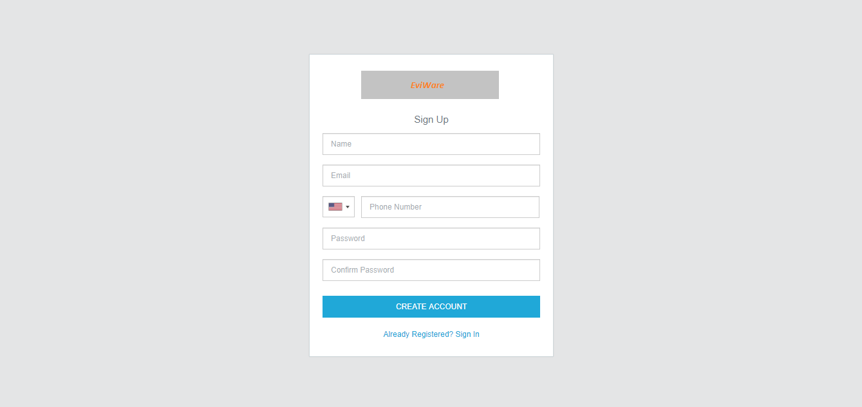

Fig: 5.1 Registration

1. **Login**

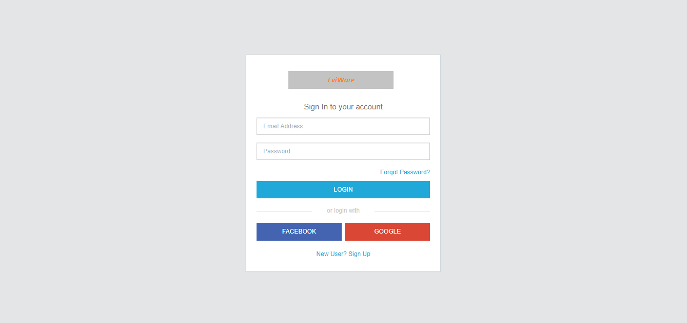

Fig: 5.2 Login

1. **Email Verification**

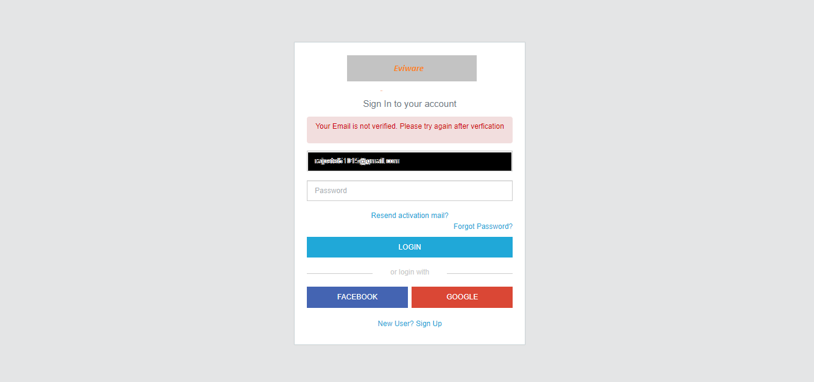 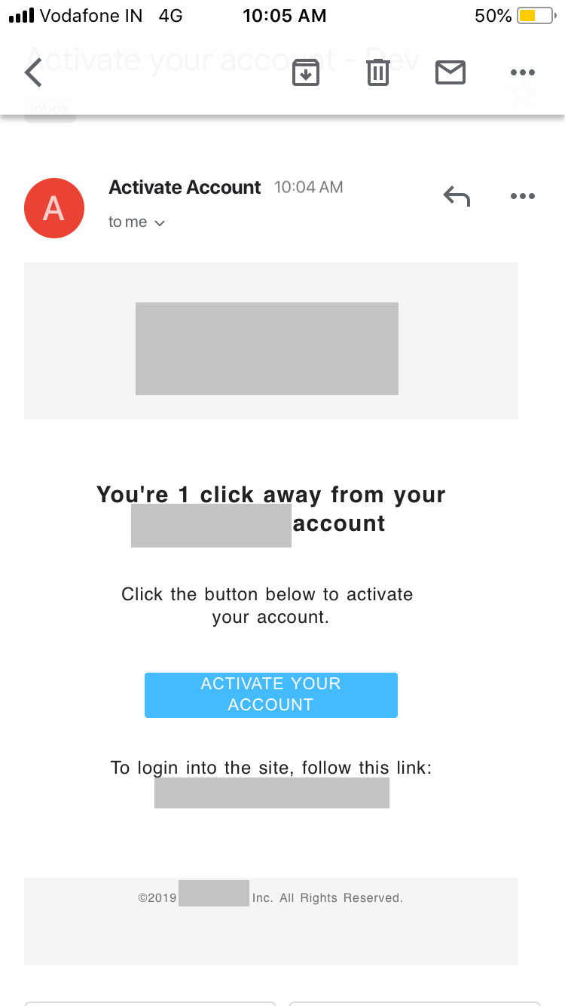

Fig: 5.3.1 Email Verification Fig: 5.3.2 Activate Account

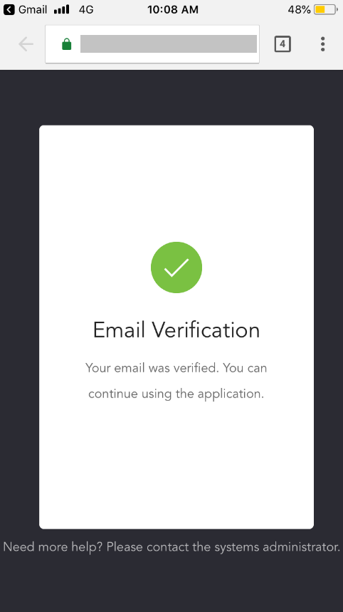

Fig: 5.3.3 Successful Verification

1. **User Profile**

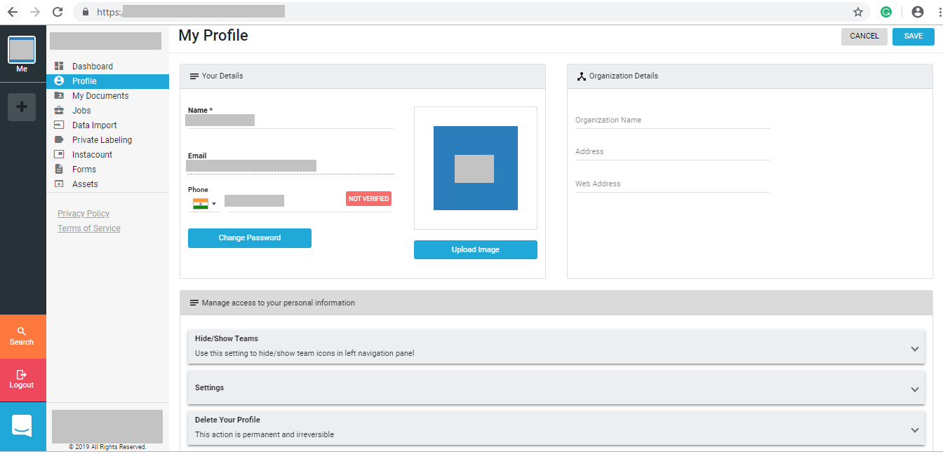

Fig: 5.4 User Profile

1. **Dashboard**

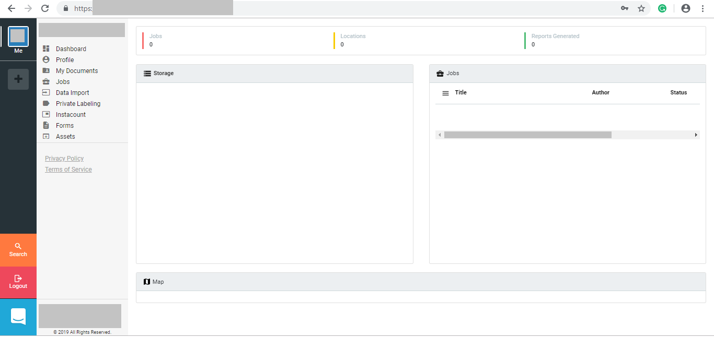

Fig: 5.5 Dashboard

1. **Job**

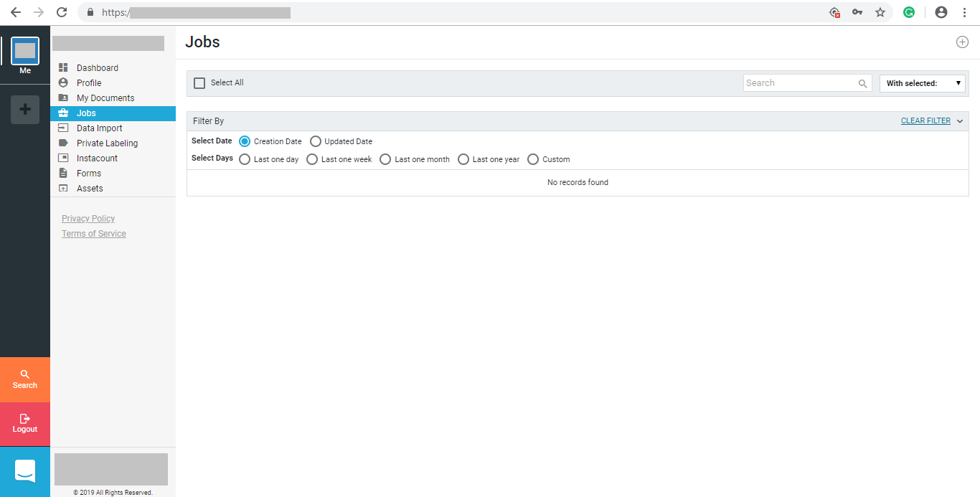

Fig: 5.6 Job

1. **Create Job (Details)**

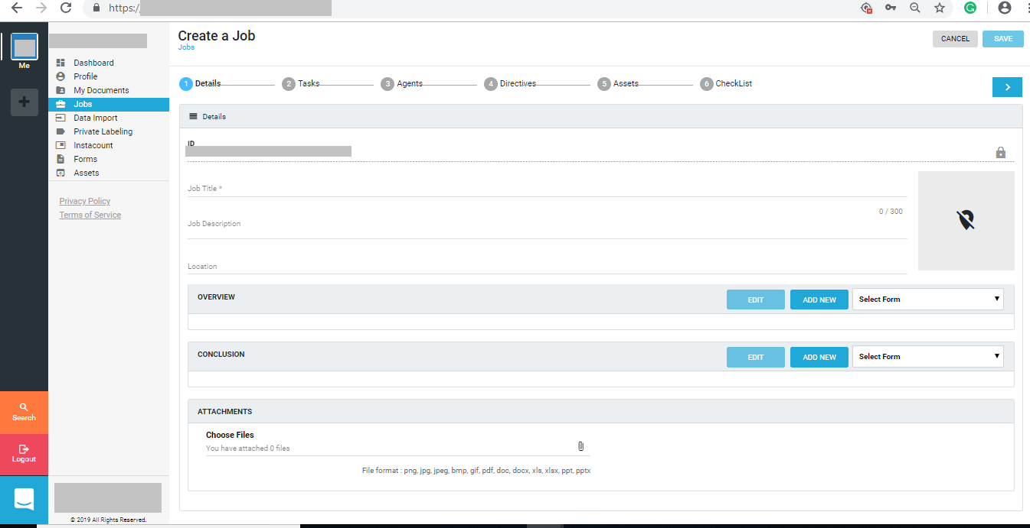

Fig: 5.7 Create Job(Details) Layout

1. **Edit or Create Overview/Conclusion Form**

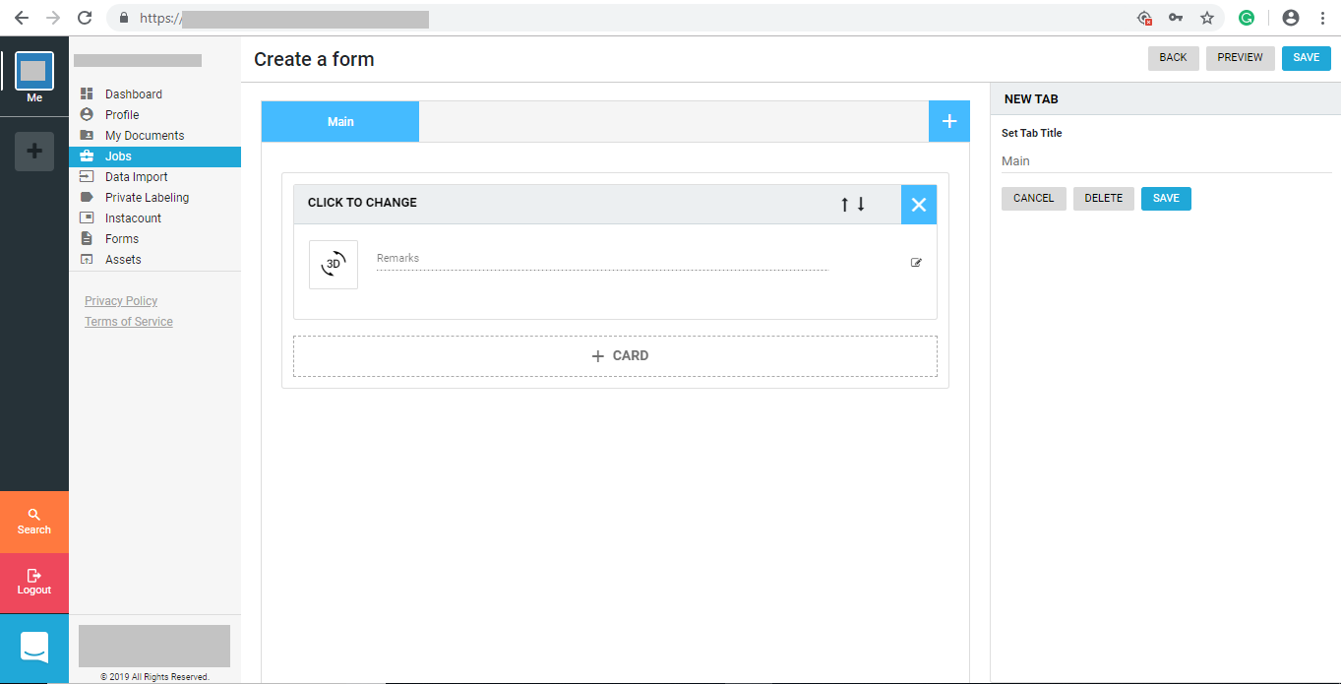

Fig: 5.8 Overview/Conclusion Form

1. **Add Fields**

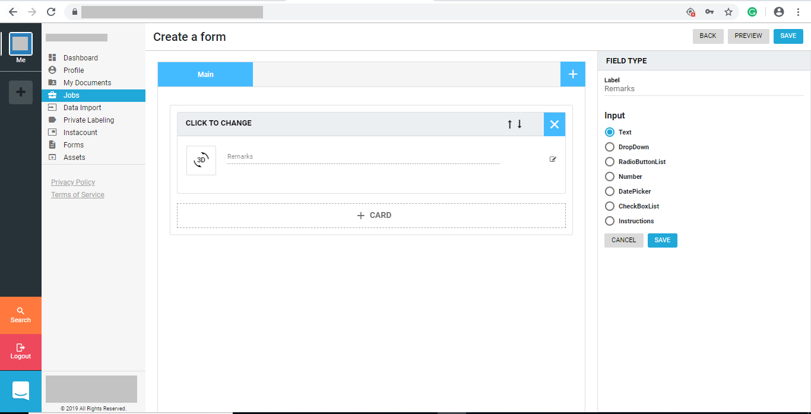

Fig: 5.9 Form Fields

1. **Create Form**

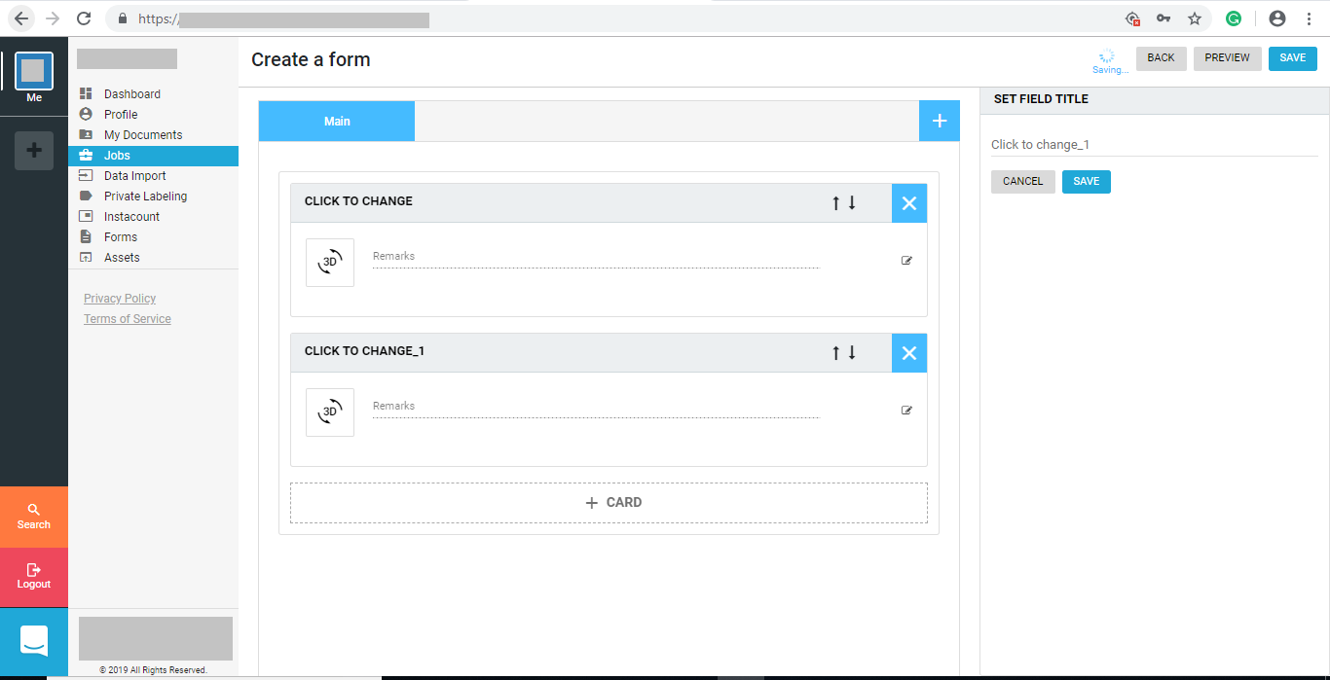

Fig: 5.10 Create Form

1. **Overview**

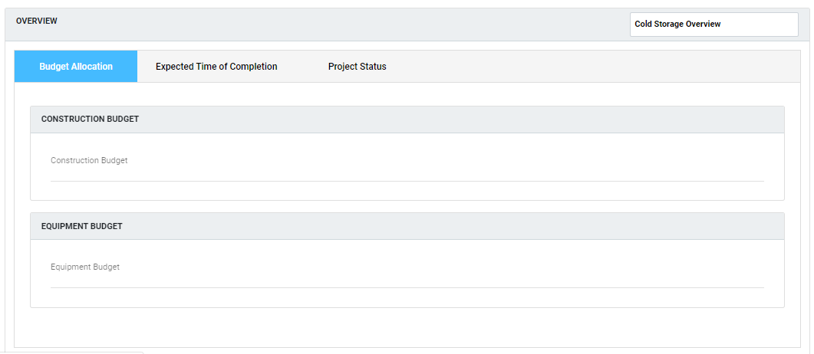

Fig: 5.11.1 Overview 1

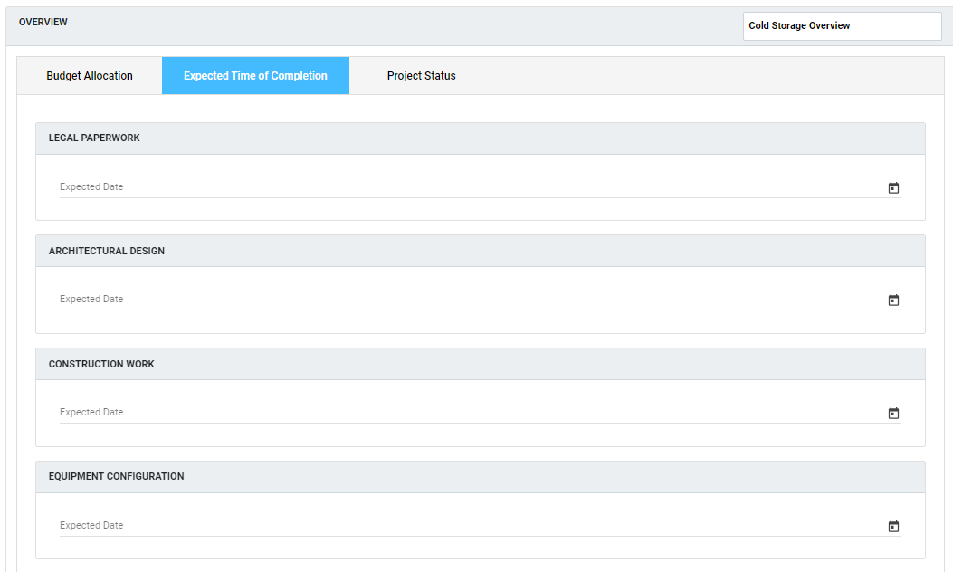

Fig: 5.11.2 Overview 2

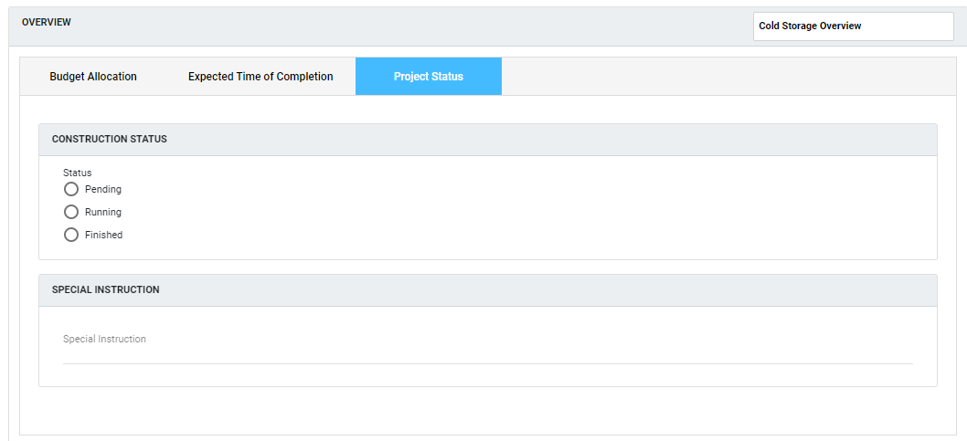

Fig: 5.11.3 Overview 3

1. **Tasks**

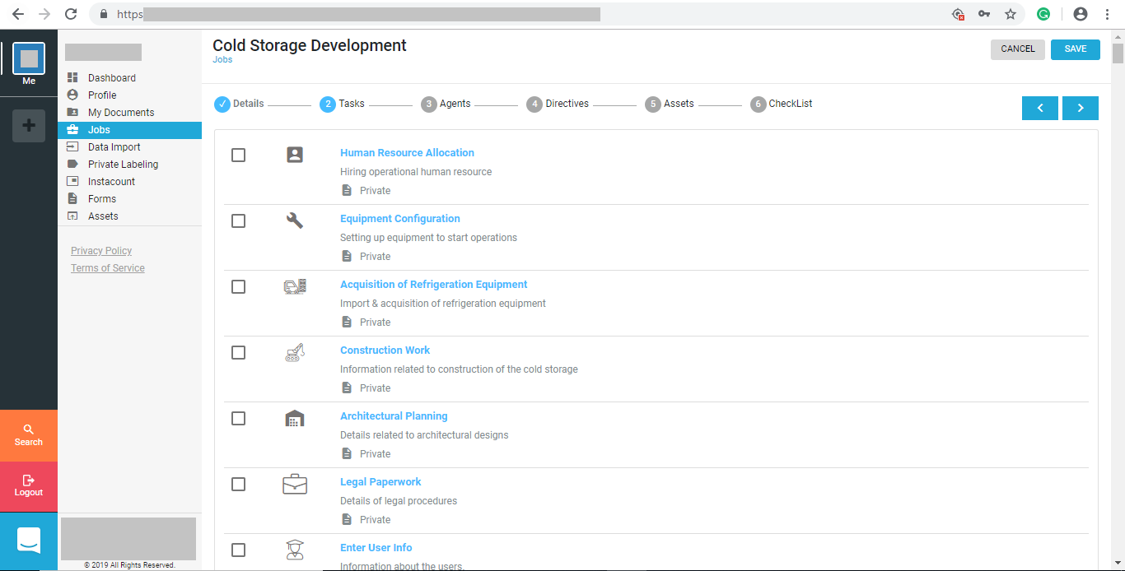

Fig: 5.12 Tasks

1. **Forms**

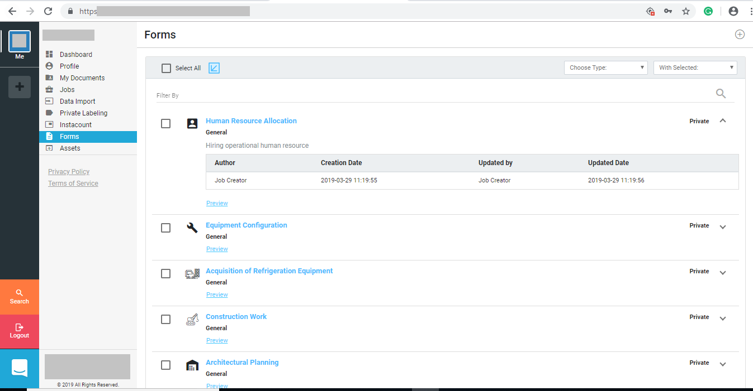

Fig: 5.13 Forms

1. **Create Form**

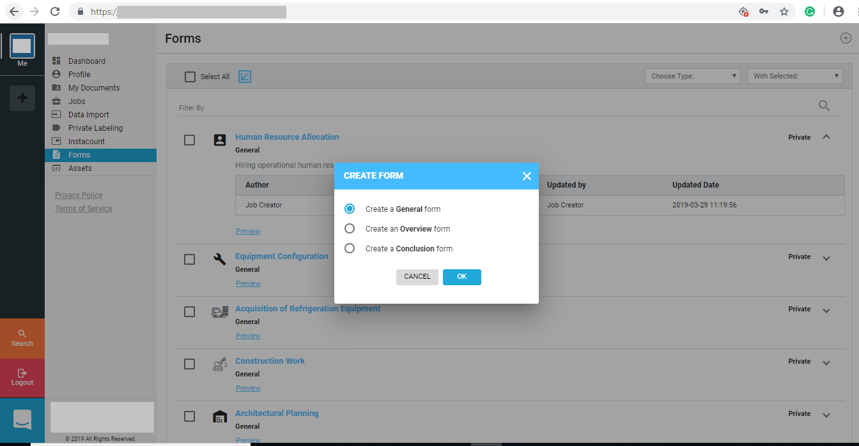

Fig: 5.14 Create Form

1. **General Form**

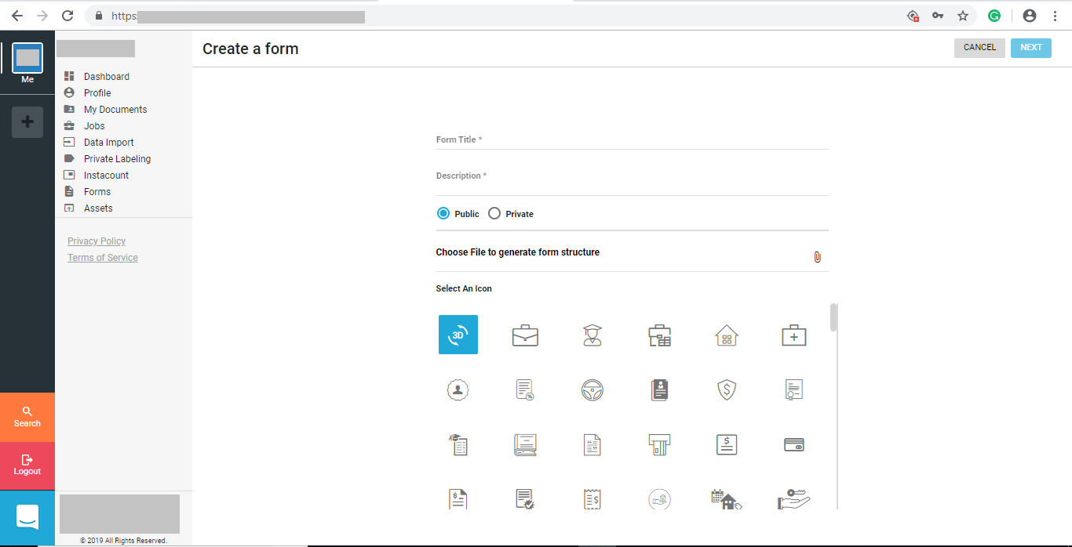

Fig: 5.15.1 Create General Form 1

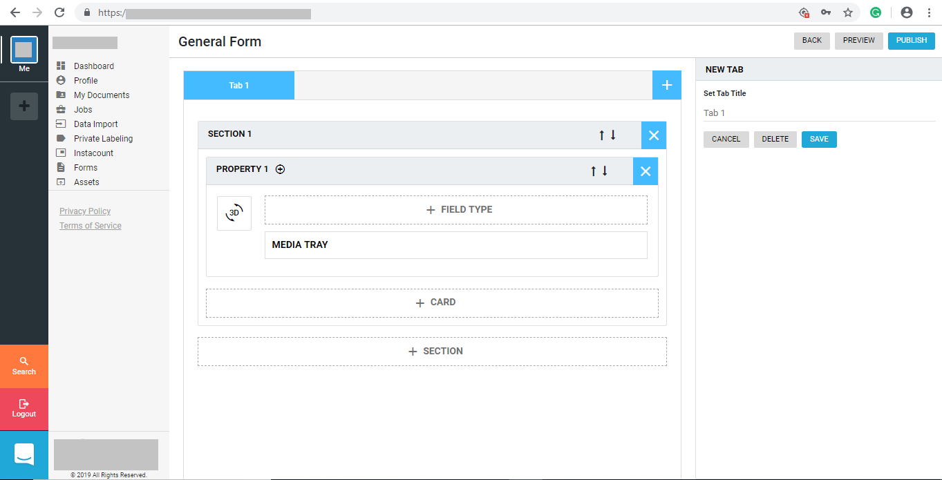

Fig: 5.15.2 General Form 2

1. **Agents**

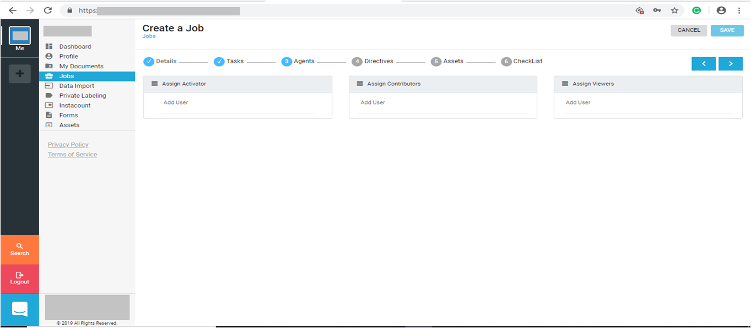

Fig: 5.16.1 Add Agents

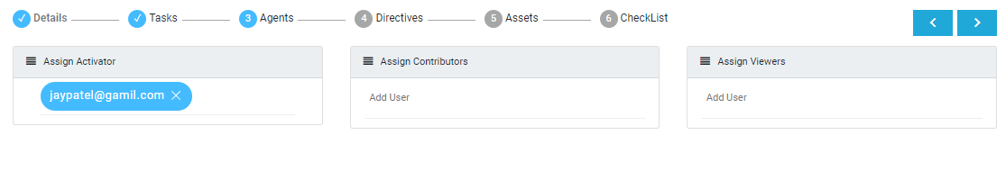

Fig: 5.16.2 Agents

1. **Directives**

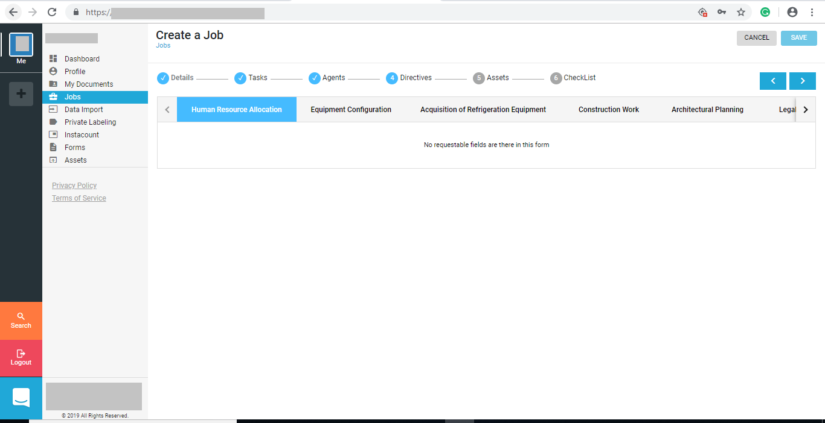

Fig: 5.17 Directives

1. **Assets**

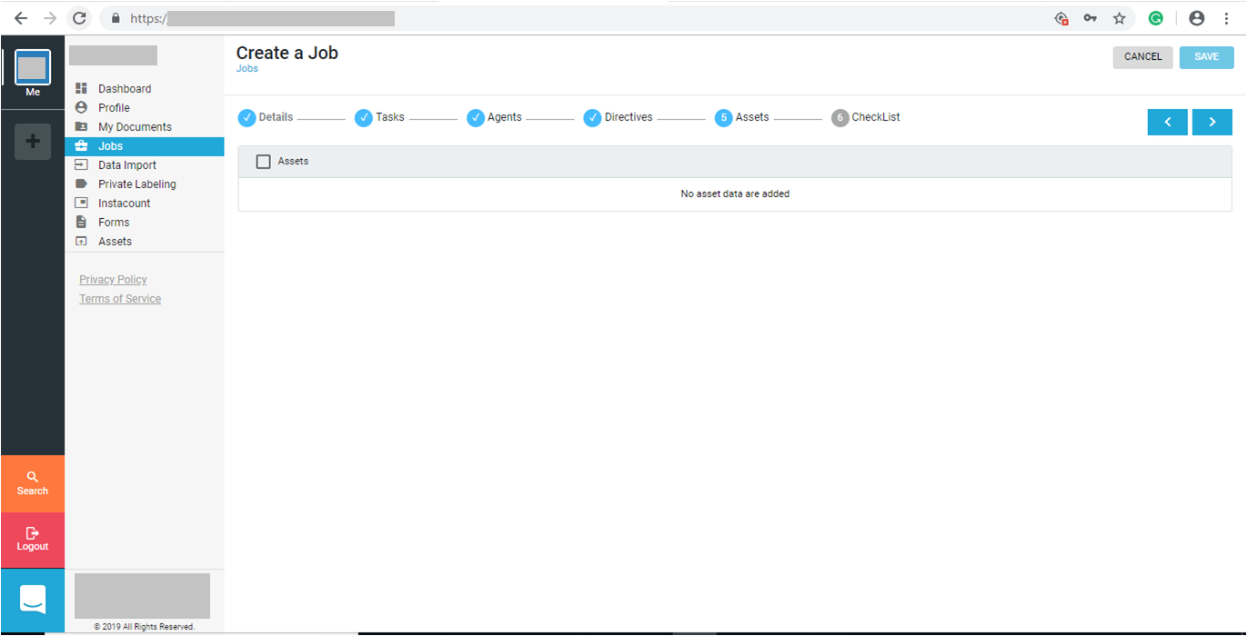

Fig: 5.18.1 Assets 1

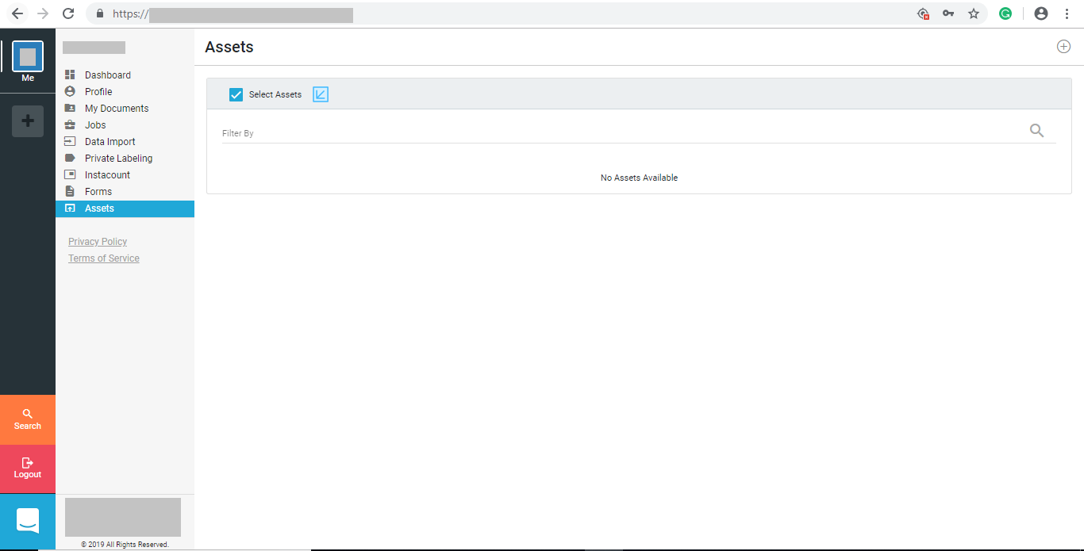

Fig: 5.18.2 Assets 2

1. **Create Assets Form**

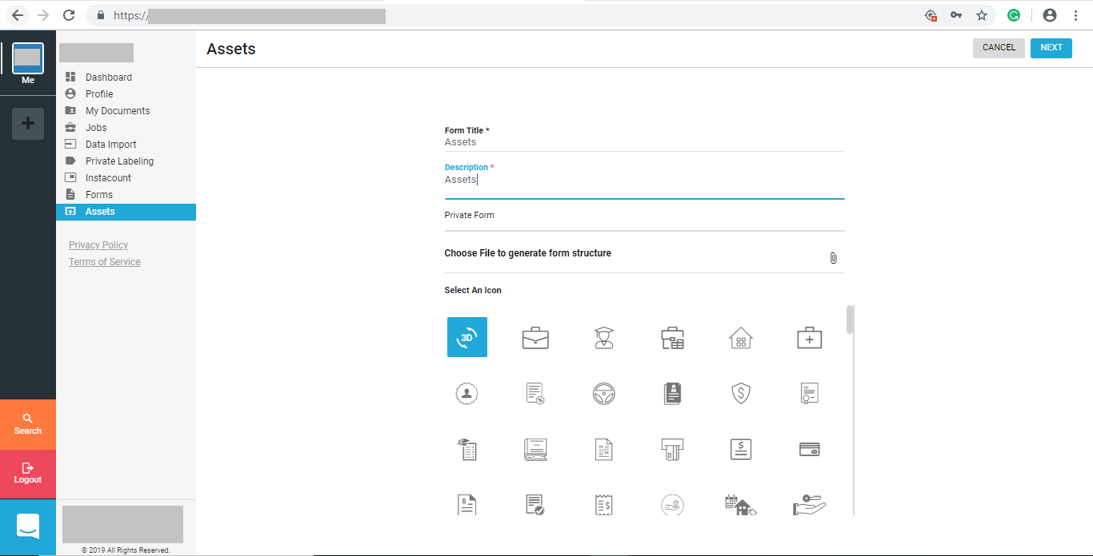

Fig: 5.19.1 Create Assets Form 1

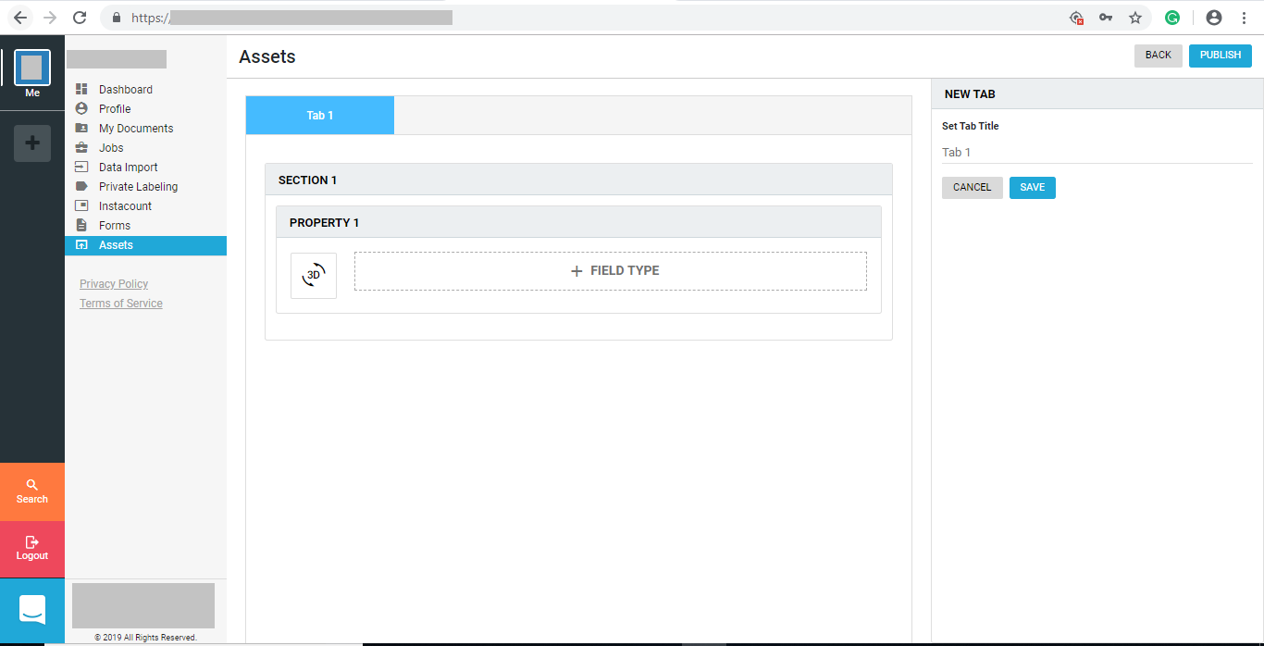

Fig: 5.19.2 Create Assets Form 2

1. **Checklist**

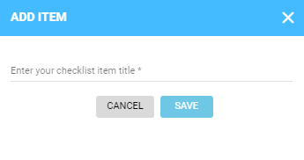

Fig: 5.20.1 Add item Layout

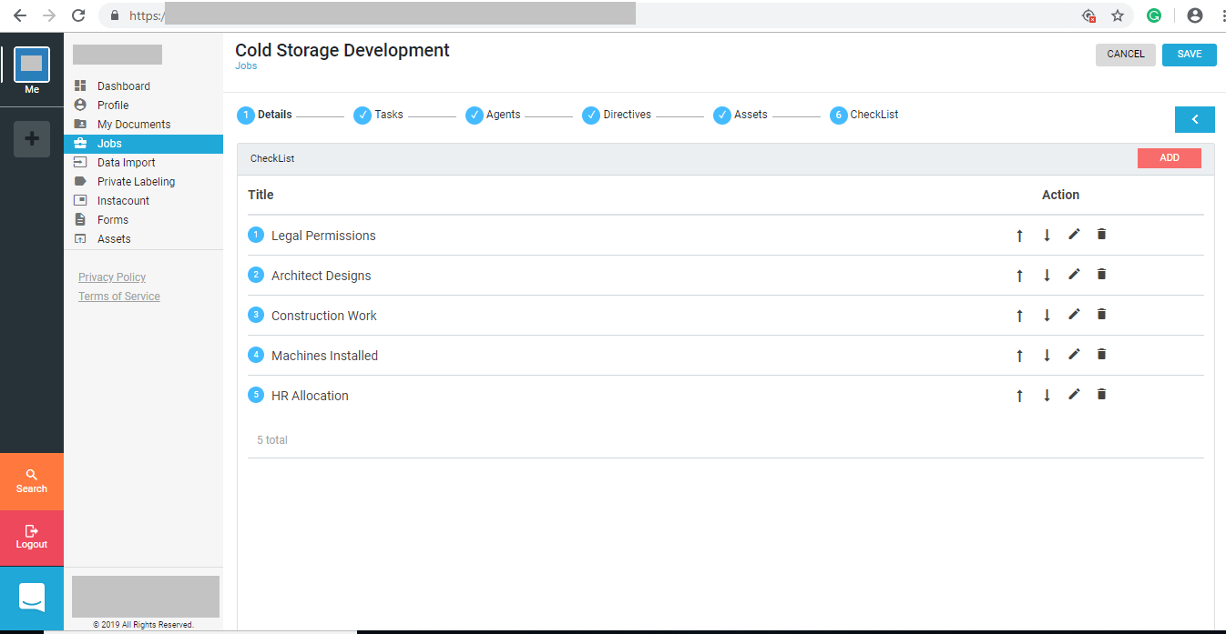

Fig: 5.20.2 Checklist

1. **Jobs Overview**

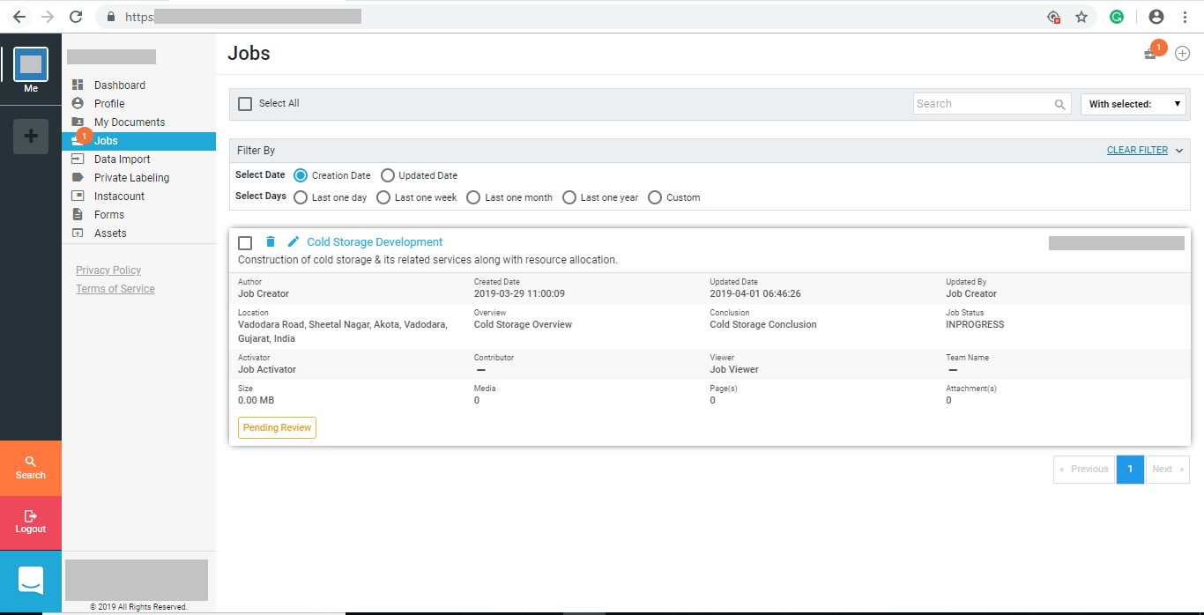

Fig: 5.21 Jobs Overview

1. **Pending Job**

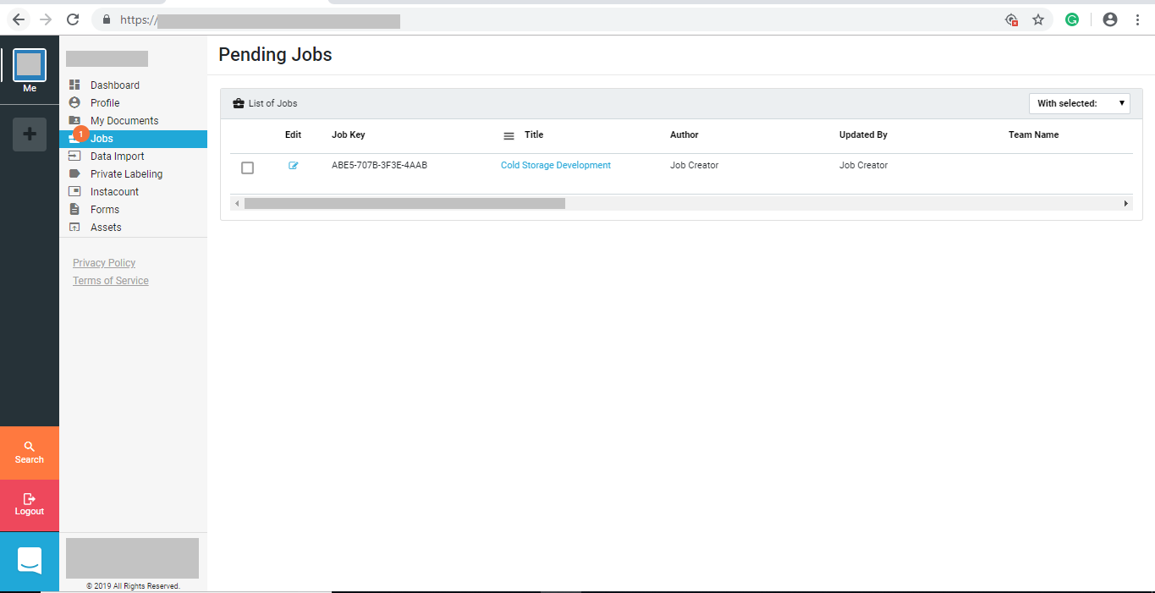

Fig: 5.22 Pending Job

1. **Job Viewer**

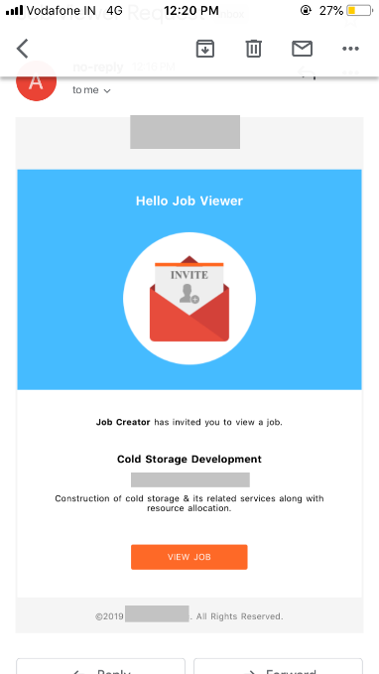

Fig: 5.23 Job Viewer

1. **Job Activator**

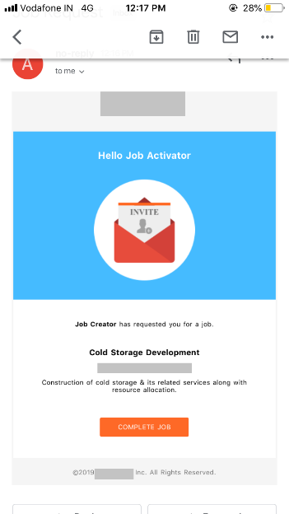

Fig: 5.24 Job Activator

1. **Accept or Return Job**

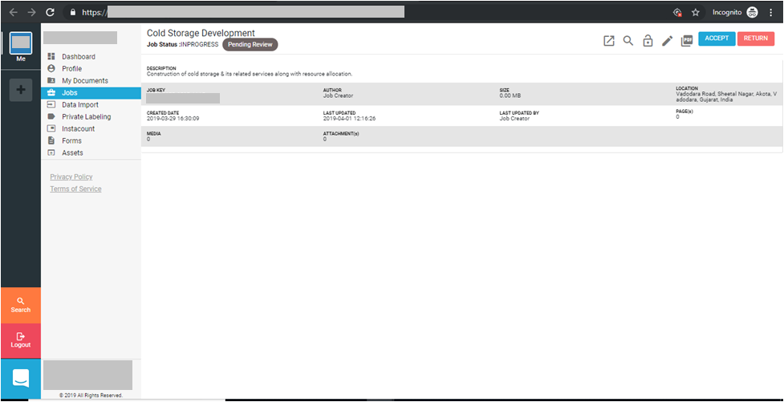

Fig: 5.25 Accept or Return Job

1. **Accept Job**

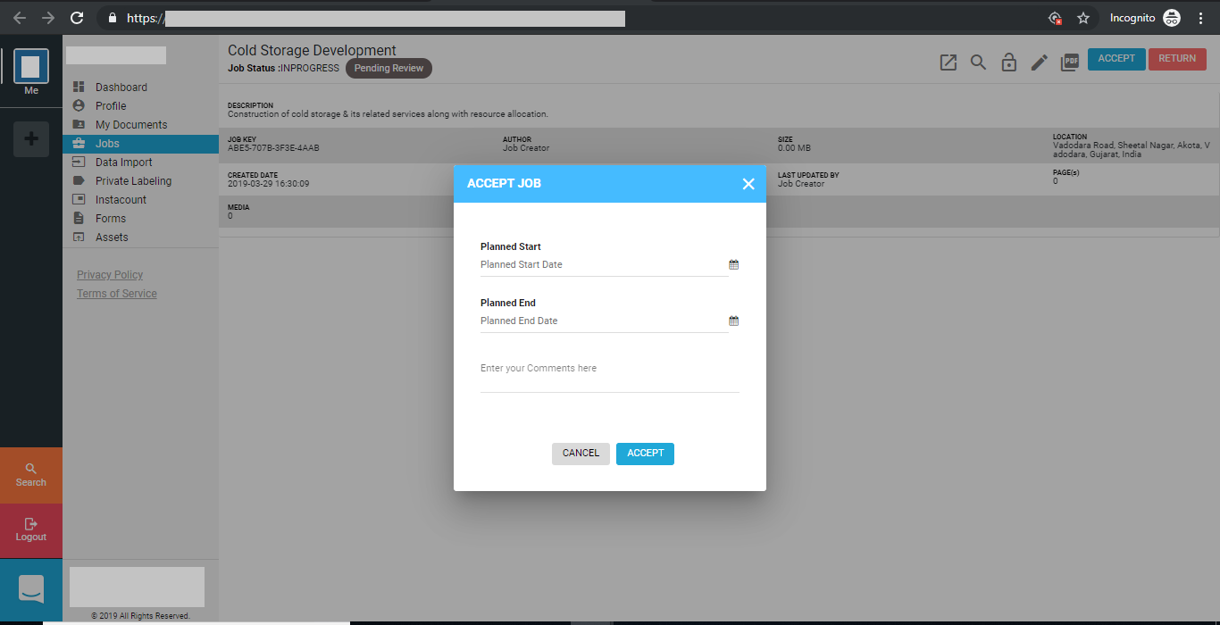

Fig: 5.26 Accept Job

1. **Job Overview**

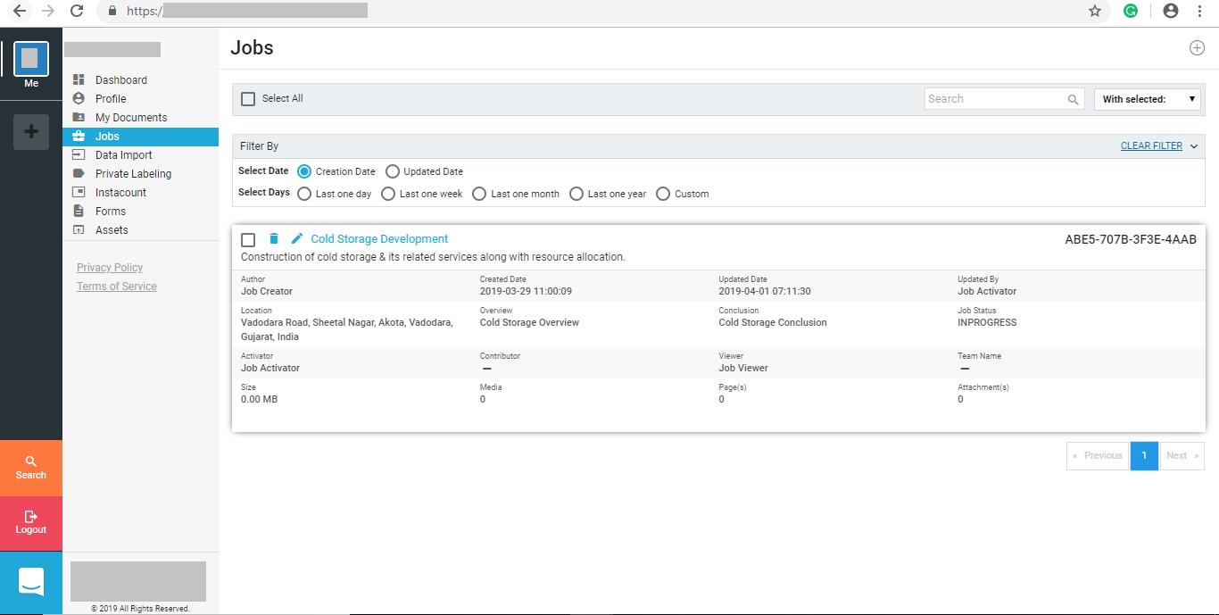

Fig: 5.27 Job Overview

1. **Job Details**

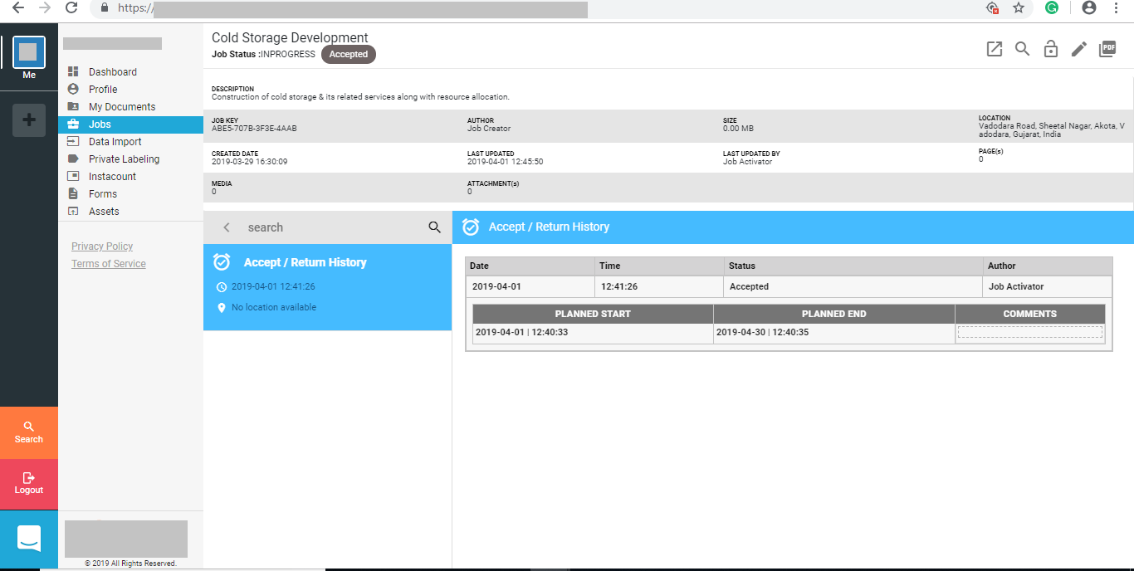

Fig: 5.28 Job Details

1. **Report Customization**

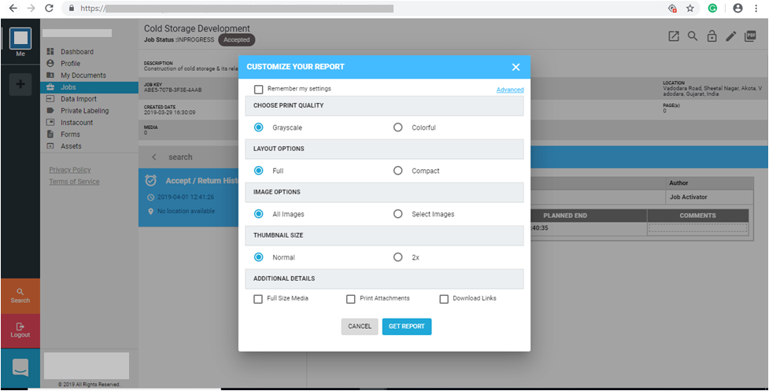

Fig: 5.29.1 Report Customization

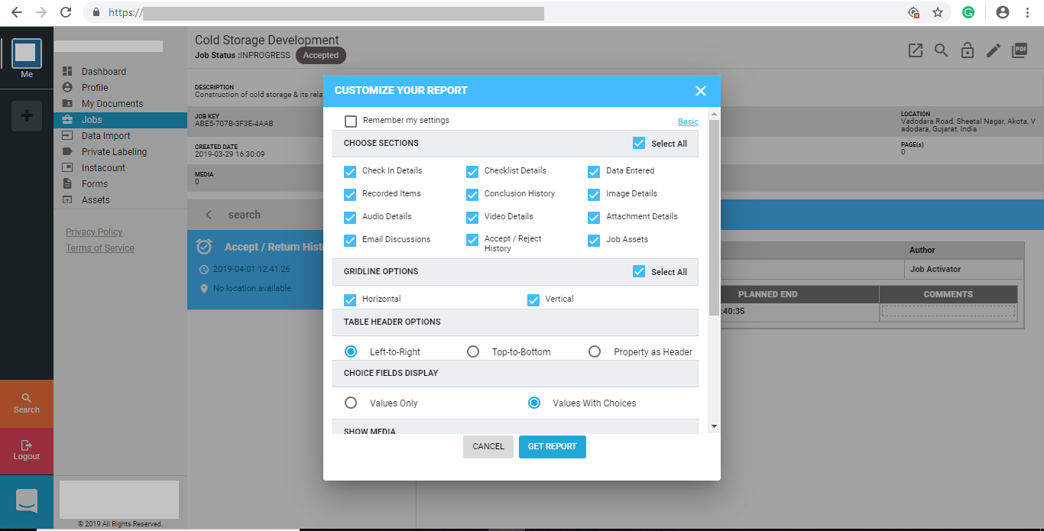

Fig: 5.29.2 Advance Layout Options

1. **Report Download**

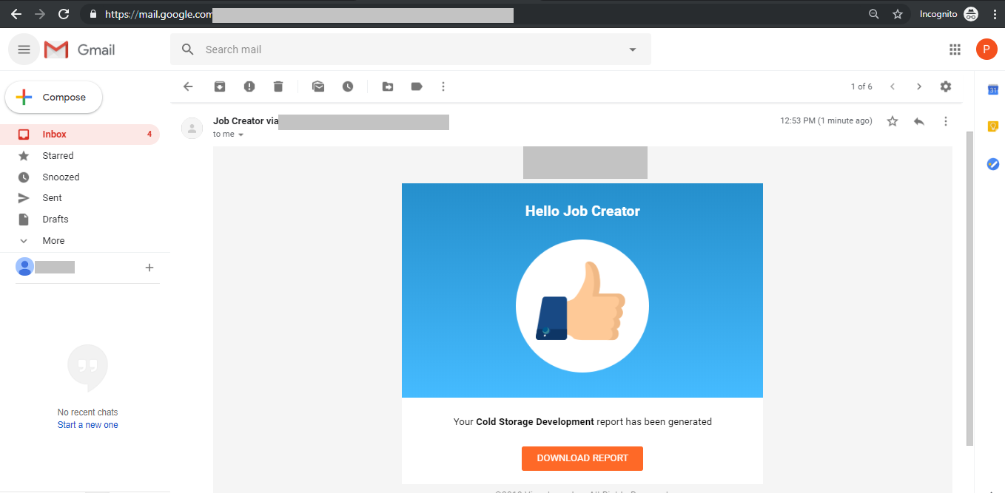

Fig: 5.30 Report Download